Virtual Masking Program
User Manual
The Virtual Masking Program has a few simple yet powerful tools to aid the user in the study and practice of a hearing assessment with masking. This manual will show you how to use the program. For help concerning the testing procedure and protocol, refer to the Tutorials.
Getting Started
The first window after running Virtual_Lab.exe provides the user with two mode choices.
- Practice Mode: This is for practicing masking and hearing testing. Users can pick a certain pathology or a random pathology. There will be nothing saved so there is no penalty for making mistakes. The “answer key” audiogram can also be shown to check answers.
- Evaluation mode: users knowledge and skills will be tested. The final results are written to a file so the instructor can grade them. The correct answer cannot be shown in this mode.
The Main Window
The top left subwindow is the audiogram. The bottom left subwindow is the audiogram. The top right subwindow shows the patient. The plateau plot can be shown in the bottom right corner when needed: from the menu at the top select Plateau Plot -> Show.
Starting a Test
To start a test, click from the top menu File -> New Patient.
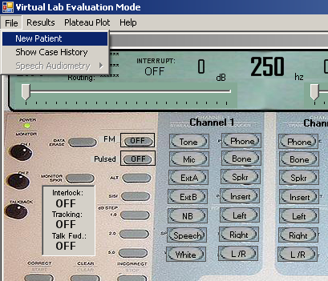
In practice mode a list of pathologies will appear, allowing the user to choose a specific one, or the first option “Random”. Evaluation mode will default to a random pathology. After choosing, the patient’s Case History will appear to give the user some background information.
The Case History can be reviewed by going to File -> Case History.
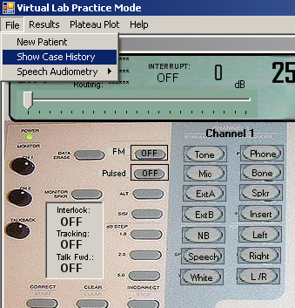
During a Test
If masking is required, the plateau plot window can be shown by going to Plateau Plot -> Show.
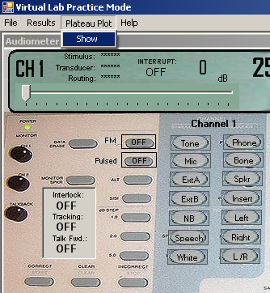
After Testing is Complete
The results obtained by the user can be checked against the answer key by going to
Results -> Show Pathology. The correct symbols will be laid over the marks made by the user. To clear the answer key and only see the user’s results, go to Results -> Show Pathology. Note that the answer key can be viewed at any time.
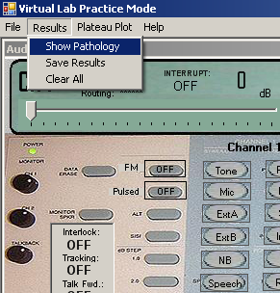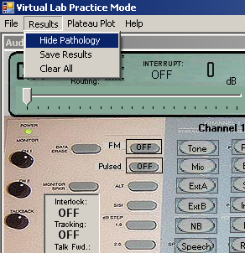
To save the results obtained from either practice mode or evaluation mode testing, go to
Results -> Save Results.
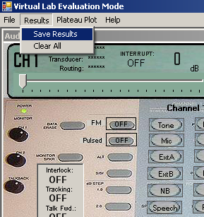
To clear every symbol on the audiogram, click Results -> Clear All.
To Find this User Manual
This document can be opened by going to Help -> Tutorial.
